Design description

The requirements of the assignment brief are to focus on aspects of the website such as promoting and selling phones and their accessories and services and the website should be targeted at anyone who wants to buy a phone. Also the website should load easily and be easy to navigate and the website should have 8 linked pages and one of the pages should have one table.

Moreover, there should be a consistent use of text, colour schemes which will be black for text across the all the pages, the background will be light blue on all the pages on the website and page styles for all the pages will be the same across the website because it would make it easier to navigate access the pages because all the pages will be easily identifiable, the templates of the design are right for the style in which I going for and the templates fit in with the purpose as well.

Also website should have some suitable and different assets and the website should have some interactive feature. Furthermore, the website should have two external hyperlinks to other webpages, the websites pages should be internally linked to each other and the website should have link to an online forum.

The target audience of the website is anyone of any age who wants to buy a phone or phone accessories so this means the website would be targeted at all ages and it will be designed for all ages as well. Moreover, the intended purpose of the website is to be able to promote, sell phones and accessories and the website would be intended to make money for the company who wants the website to be made, another reason would be that website want to get more well known by have big companies on the website.

This will be done by promoting big phone companies and selling phones on the website. Furthermore, background colour across the whole website will be light blue. The font will be black and no smaller then 12, the font style will be Calibri (Body).

There are some alternative solutions for the website and the first alternative solution will be that I can change some of the assets like one of the phone companies can be changed or one or all the social media sites can be changed to a more well know site or company. Also one of the pages might be a forum page so the forms can have one site solely based on them but one of the pages that I already have would have to go.

Justification for my design decisions

Alternative design

The alternative designs were rejected because on my design I wanted to have the assets to be well known phones companies so the customers would get a bigger list of phones they can buy which we do not sell and on the alternative design the companies are less well known.

Also the pages are laid out on my design so they are more accessible to all ages this is because then the website would get more people looking at the website. Therefore, this would increase the sales of the phones and the accessories and the alternative design layout was harder to use because there were more links and images which made the design harder to use and not very professional.

Intended purpose and user requirements.

The website meets the intended purpose by having an easy to use layout for all ages and have well known links to big phone companies which make the website look more professional and a trusting website. Also the website has a page which helps customers tell their opinion on the website which will help the website get more well-known and make the customer base grow.

The website will meet the user requirements because in I think the website has a focus on the selling and promoting of phones and the accessories and this is down to the page layout and the content the pages hold and the website is able to target anyone who wants a phone because the layout is easy for all ages and each page has its own focus like one page is just about selling phones and another pages is just about selling accessories and this makes the pages easy to understand and what they’re about.

Also the website is easy to navigate because there are links to every page on each page which make it easy to go back to a page which you have already looked at. The website and pages should load quickly because there are not too many large images on all the pages and there are not too many links as well so I think the website will load at the right speed.

Also the website has eight pages and they are all linked and the services page has one table which has all the services and a description on how to use them. Furthermore, I have decided to choose light blue as the background colour as it is not only easy on the eye but does not cause eye strain to the customer and the font I have choose is Calibri (Body) as it is simple in design and easy to read.

The font size should be no smaller then 12 and the words will be black as it is a perfect contrast to the light blue background. This style I have chosen will be used right across all web pages so the customer’s new what website they are on at all time.

Also the website has multiple assets and they are linked to other big phone company’s websites and the logo will be a digital graphic and there is a video on the site and the video is a guide on all different types of phone. Also there is an interactive feature on the customer feedback page and it work by you interacting with customers and getting their opinions on the website and you can write your own feedback as well.

Also the website has 7 external hyperlinks to phone company websites and these links are located on the phones page and there are some links to social media websites and these links are on the customer feedback page and on the customer feedback page there is a link to an online forum and there is a link to a video on one of the page, there is a link to an audio track on one of the pages and the video is on how to fix the areas of the phone like the software and hardware of your phone.

Constraints

Moreover, some constraints that might stop me from making the website are that the software which you can make the website from does not work for weeks or that the software that is installed on the computer would make it harder to make the website.

Also another constraint is that if some of the assets that I wanted for the website are under copyright this would mean I would not be able to use the asset and have to find a different one.

Also some other constraint would be if the software I will use for the making of the website did not have a feature which I would need to make the website and if my computer at home did not have the software to make the website and this means that I would be limited to the computer at the college. Also another constraint would be that the college was closed for some reason like weather and this would mean that I would not be able to work on the assignment.

Also some other constraints which I would have when making the website would be that I do not learn the software in time so when I come to make the website I will have to learn and create the website at the same time and this would slow down the making of the website.

File structure

This is the unit 13 folder where all the assignment is.

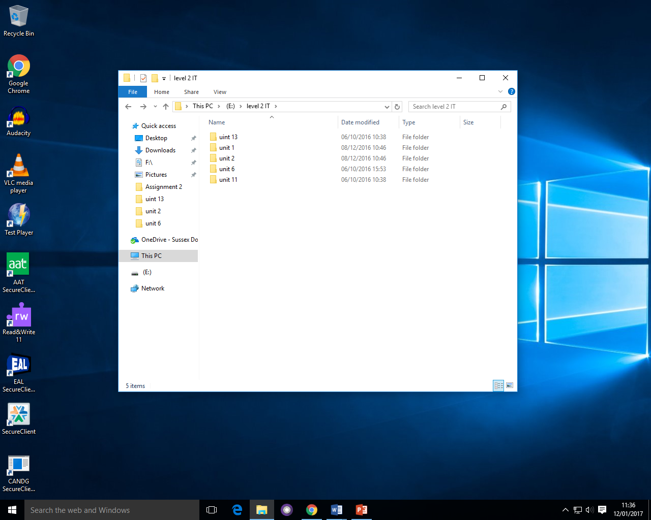

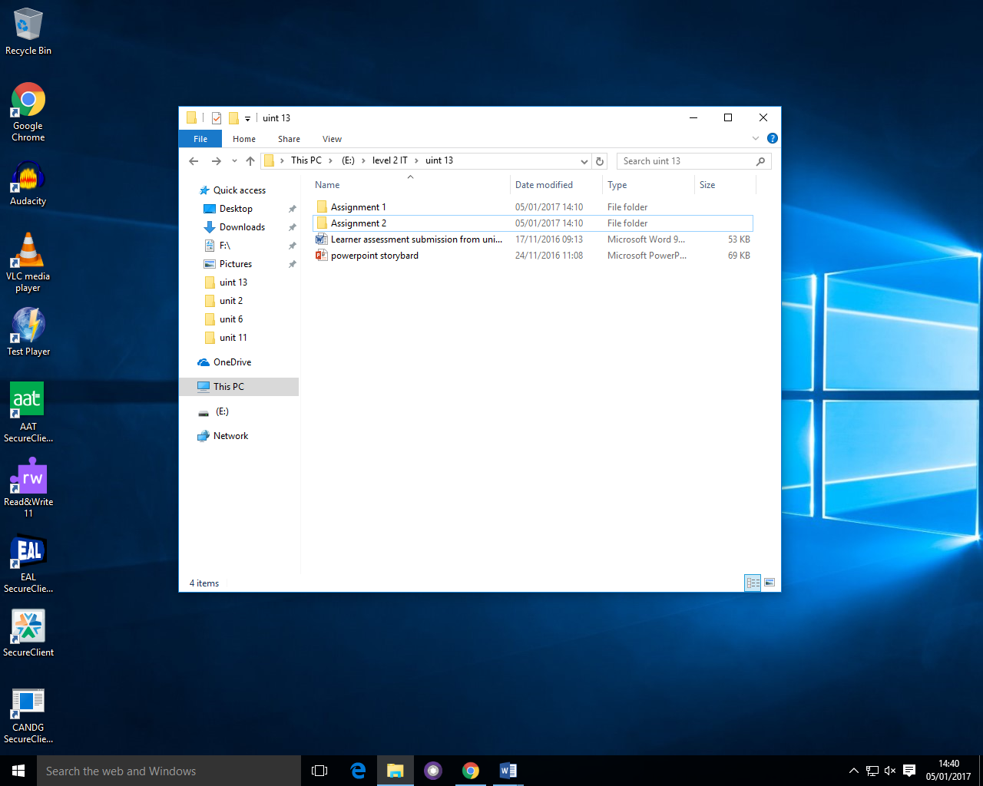

The Is the folder which all the assignment 2 work is.

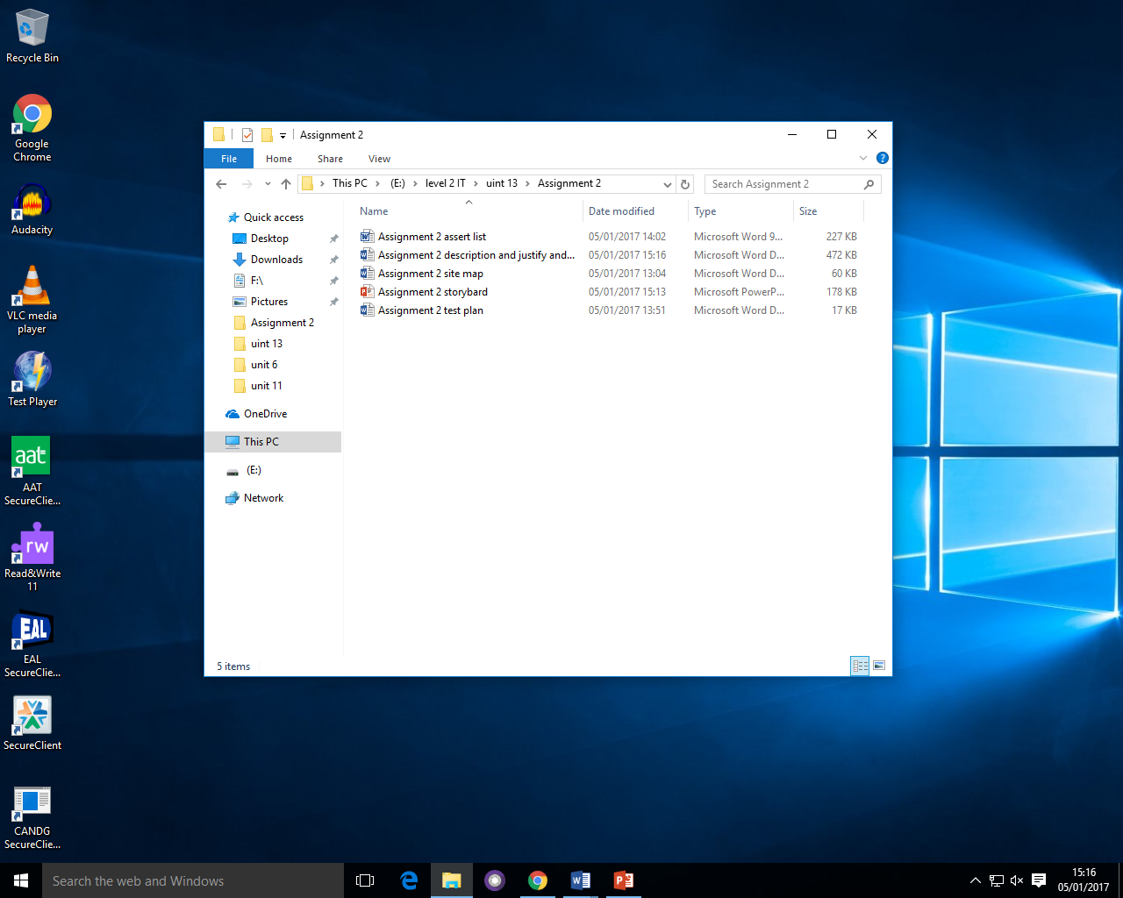

These are the different documents in the Assignment 2 folder.